**Web Design – CA2 part 1 - Report**

**Daniel Coxon - x00131957**

**Micko Corbantes - x00121815**

**Thomas Ankers - x00119677**

**Topic** – **A website that reviews and sells the latest computer games.**

We began the design process by thinking about the ease of navigation throughout the pages on the site. We wanted it to be simple for the user and for them not to be overwhelmed by menus and different ways to navigate, our aim was to keep It fluid and obvious and have nothing ambiguous.

We began by going online and looking at different websites and even different genres of websites. This was done so we could get a general idea of what all websites try to achieve for their finished product, and we found that to be ease of use and navigation. We decided that the pages we would need are an ‘index’ (Home page), a ‘Products’ page and a page for each product respectively.

Our main target audience would be gamers of all ages and genders. This is the main reason why we made the site not overly complicated. The site could be used by parents buying games for their children as Christmas/birthday presents so we didn’t want the site to be daunting to use for this audience. The site is suitable for everyone and usable by everyone.

The colours we went for are neutral and plain looking, mainly black and white, we found this to be easy on the eyes. Another reason we did this is because we wanted to use lots of images which make the site vibrant, colourful and alive.

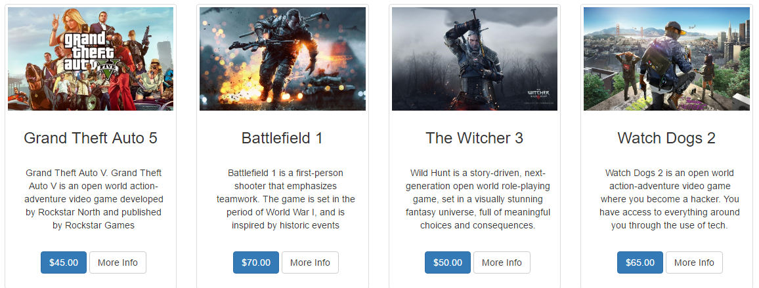

**Our Hierarchical Site Structure:**

**item**

**item**

**item**

**item**

**Index**

**Products**

**The Navigation Bar:**



We kept our navigation bar simple, this makes it easier for any user to access the different pages that we have. Simplicity is best when it comes to navigation bars we felt as users of all computing aptitudes would be accessing our website.

**Index Page:** With our Index page or “Home” page, we wanted to give the user a slight inclination of what our website is about, using poster style pictures and images from games that we sell and that we have reviewed already. With the Index page, we all felt that all-round contribution was necessary so that we could imprint all our ideas onto our webpage. This led to a few arguments on what images to use and how to display them but we took a bit of time to ourselves and later convened and we were able to work out a solution that we all agreed upon. On our home page, we also decided to let the user know what platforms of games that we sell. We decided that we would use that platforms that we were most familiar with, Thomas was most familiar with the Xbox so he was entrusted to write about the Xbox. Similarly, due to Dan’s fondness of the Playstation’s design and specifications, we delegated that he should write about the PlayStation. Micko felt that he had the most experience with PC gaming so that led to him writing about the PC gaming platform. The footer of the webpage doesn’t have much to do with the page and nothing of note is on it, the footer is just a default.

**The Main Products Page:** The main products page was where the primary information about our website was held and as such, it was a great source of debate between the three of us. What we could agree on however was the first image, we thought the Star Wars picture was enough to awe the majority of our customers on arrival at the web page. The high definition pictures were the thing we all enjoyed choosing and we felt as such it should be a primary theme in our website. After that we have the “Top Picks Right Now” section, it is a recurring theme in many other websites and as such we felt we were justified in adding it into our webpage.

**The Sub-Products Page:** The sub-products page was based off of the main products page and that is where we got a lot of our content from. The four games had their own pages, for the design we put a sidebar in to change things up a bit, just like with the navbar on the home page we kept it simple. We felt this page was the easiest to design and agree upon and we all enjoyed making this page/pages. The pages were all the same design so that lightened the workload on all of us.

**Sketches of our Design:**

**Index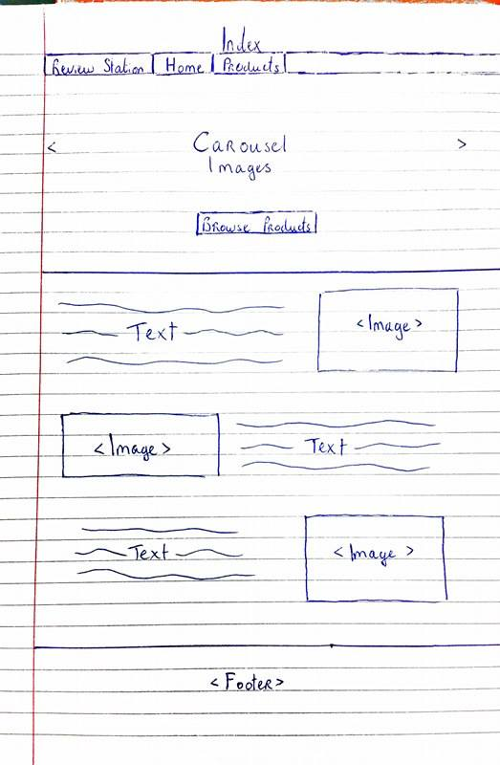: Products:**

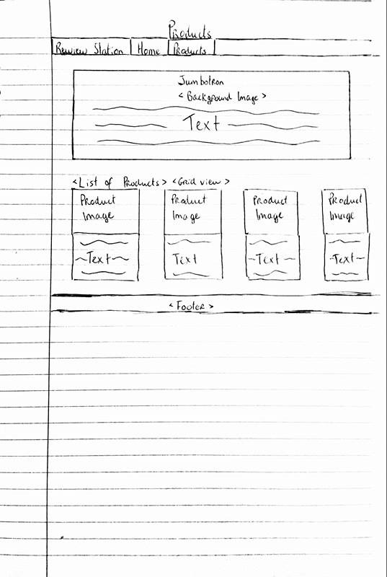

**Product Item:**

